Things that work:

Cylinder (everything)

Anti Aliasing (including pushing 1,2,3 to set the level)

Note: Changing the antialiasing level sets the background color to white for some reason

Shadows

Things which don’t work:

Dual viewports

I was able to set out the basics on how this would work, but both raytracers print to the same

half of the screen.

Example Outputs:

AntiAliasingLevel = 1

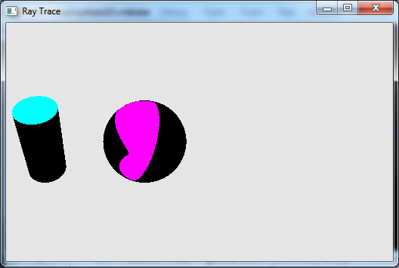

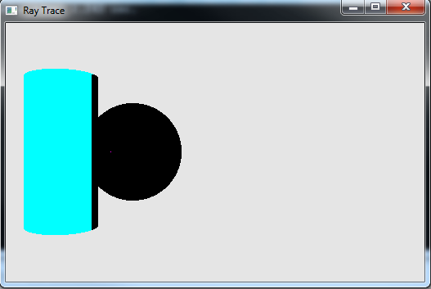

AntiAliasingLevel = 2

